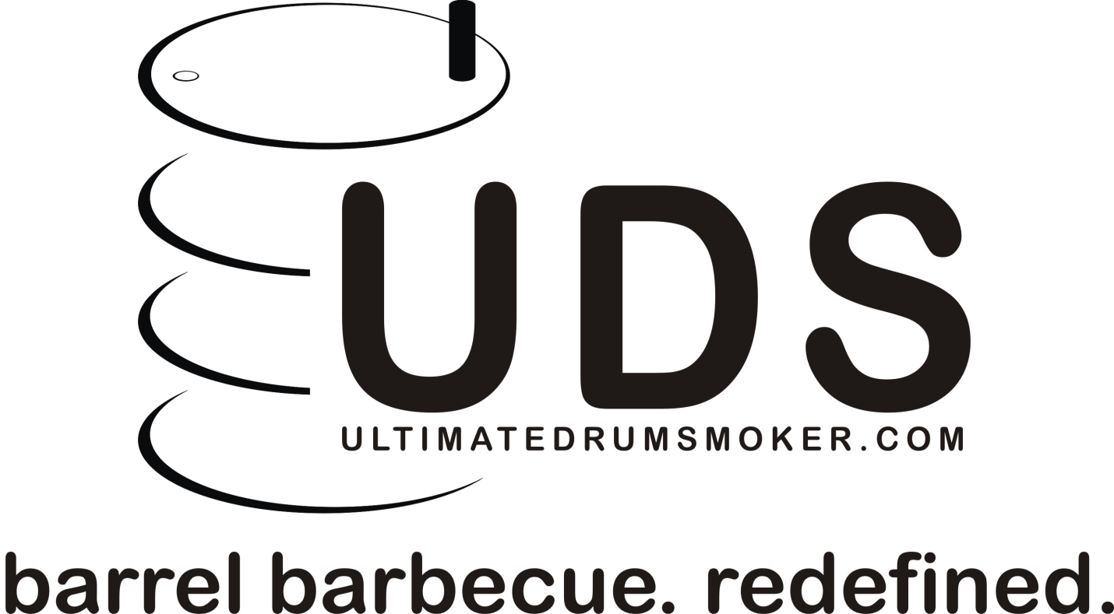

Drum Smoker
User Guide

Using a UDS (Upright Drum Smoker)
Welcome to the world of BBQ! Or, as some might say, welcome to the low-and-slow addiction. Barbecue, a.k.a BBQ, is the only recognized year-round sport. From backyards to competitions with $50,000 in prize money at stake, many people share a passion for cooking with live fire. For a lot of people, BBQ is not just about great food. It is about the afternoon sun shining in the backyard, the pleasant aroma of burning hickory wood permeating the air, playing catch or croquet with the kids or mowing the lawn and weeding the garden while keeping an eye on the smoker thermometer. It’s about a human physically controlling live fire, which in and of itself is fascinating enough. However, you can’t have a BBQ without cooking something, so ultimately you come to the food. And the challenge. The challenge of making the fire do what you need it to do to produce some of the best meals you could possibly eat. The challenge of turning out tender, juicy chicken thighs with “bite-through” skin that doesn’t flap down over your chin when you take a bite, or that quarter-inch slice of brisket that is fork tender and juicy, but yet holds a slice without falling apart, ribs that are oh-so-succulent, pulling cleanly off the bone, yet just firm enough to not be mushy. It’s about that challenge of creating a beautiful smoke ring…that pink band of color around the outside of a piece of smoked meat that looks so cool and starts the tummy to growling. And the bark…that almost black, almost burnt-looking layer of spices and seasonings, meat juices, and smoke that have congealed together on the surface of the meat, forming a crust that makes your Boston butt or brisket look like shriveled up shoe leather, but when sliced open you find tender, tasty, smoky meat that makes it worth all the trouble. Yep, that bark is half gone by the time it gets from the smoker to the kitchen, crunched into oblivion by the BBQ cook who is “just checking” to make sure it’s right. Yeah, buddy!!! That’s what I’m talkin’ about, right there!
This all doesn’t just happen overnight. Just like learning to play baseball, or ride a bike, learning to BBQ well takes a lot of trial and error, a few disasters, and a few emergency microwave corn dog backup Plan B’s, but mostly you will come to the table with a huge smile on your face, amazed at what you actually accomplished, out there on the patio.
The term “UDS” is an acronym for Ugly Drum Smoker or Upright Drum Smoker. The UDS is one of the most versatile, easy-to-use pieces of BBQ equipment out there. Many competition cooks fill their large trailer pits with brisket, ribs, and chicken for the masses, while the judges’ food gets cooked on a UDS. However, most drum smokers are, well, ugly, not to mention crude. They work well, though. That is why I had the idea that a drum smoker should be a thing of beauty that would last a lifetime. On this idea the Ultimate Drum Smoker was built. The redefinition of the UDS. The following pages will help you understand more about how to use your UDS, as well as provide a few tips on BBQ in general.

Please read the following warnings!
- The UDS is a smoker, not a grill. Never exceed 300*F. Doing so may scorch the paint.
- VERY IMPORTANT!!! WHEN OPENING THE LID, DO WHAT YOU NEED TO DO AND CLOSE IT AGAIN AS SOON AS POSSIBLE!!! Opening the lid provides unlimited oxygen to the coals. Leaving the lid off will result in the coals getting hot enough to ignite the grease seasoning buildup on the walls and heat deflector of the smoker, resulting in an inferno that will RUIN YOUR SMOKER!!! It is best to close the vents about 5 minutes before opening the lid to starve the coals of oxygen, giving you a longer working time before the coals get hot.
- If your smoker has side shelves, do not use them to lift the smoker. They are capable of holding a plate, thermometer, or spatula, but will not support the weight of the smoker full of charcoal.
- Be very, very careful not to hit and bend the thermometer stem when lowering the fire basket or bottom grate into the smoker. If damaged, the thermometer will not read accurately, and you could overheat the smoker and burn the paint.
- After using the Ultimate Drum Smoker, do not overeat. Overeating carries with it a plethora of health risks including but not limited to elevated blood pressure, breathlessness, increased heart rate, etc… Seriously.
What you will need:
- Charcoal
- Smoke wood
- A chimney lighter, or fire starter cubes
- An instant-read meat thermometer

- Lighting your UDS
- Until you are familiar with your UDS and how it works, allow 2 hours or more for lighting the smoker and getting the temperature stabilized before you place meat in the smoker.
- Remove the lid, grates, and charcoal basket from the smoker.
- Fill the charcoal basket almost to the top with charcoal. Any type of plain charcoal briquettes or lump charcoal will work. Do not use Match-Light or other self-lighting briquettes! These are impregnated with lighter fluid and will impart a petroleum flavor to your food as they burn. The basket is large enough to hold a full 17.6 lb bag of lump, or approximately 12-15 lbs of briquettes. Kingsford briquettes in the blue bag are a good charcoal to learn with.
Chimney lighter method
- The best way to light charcoal is with a Weber chimney lighter or similar. Follow the instructions for your chimney and light 1/3 to ½ of a chimney full of charcoal. Again, lighter fluid is not recommended. If you use lighter fluid, make sure the coals are well lit so that the fluid is burned off before placing in the charcoal basket.
- Once coals are lit and are covered with white ash, or glowing red, make a small well, or hole, in the center of the unlit charcoal in the basket and pour the lit coals into a neat pile in the well, directly in the center of the basket.
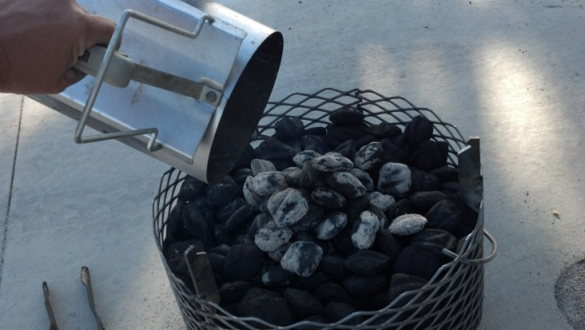

Fire starter method
- Alternately, you can use a fire starter cube or square. Tuck the fire starter into the top of the charcoal in the center of the basket. Light it and after a short while the coals around it will begin to light. Wait until the coals are well lit in a 3” or 4” diameter area in the middle to place the basket in the UDS.
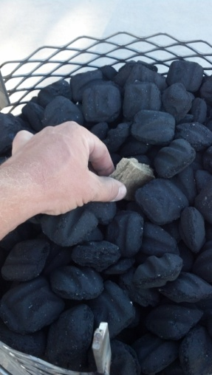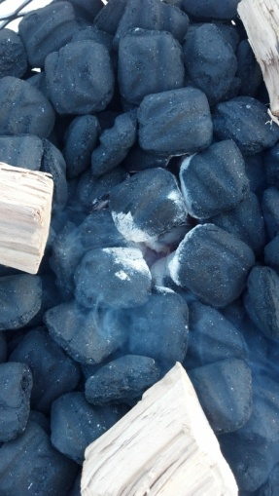
- After adding lit coals to the charcoal basket, sprinkle a few chunks of smoke wood evenly spaced on top of the charcoal basket. Place one chunk directly on or very near the lit coals, then as you go around place each chunk slightly closer to the outside of the basket than the last, so that as the fire creeps from the center outward, it can light the chunks one at a time without burning them all at once. Another method is to place the chunks at various levels in the charcoal. This is preferable if you are using the chimney lighter method, as the coals generally burn from the top down so by placing wood deeper in the basket you will get more consistent smoke throughout the cook. You will learn as you go how much smoke you prefer. Start with less and use more next time if you would like a stronger smoke profile.
- Once smoke wood is added, place the heat deflector on top of the basket. It should snap into the brackets. Carefully lower it into the bottom of the drum, keeping an even air space all the way around the basket.
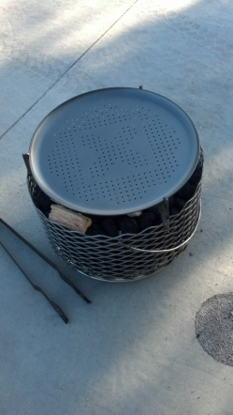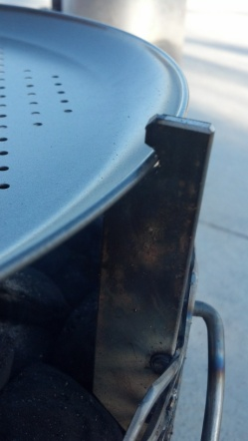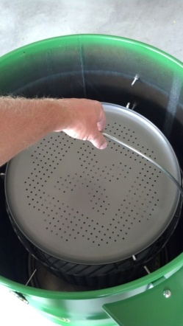
Note: The heat deflector is completely optional. Some people never use it, others use it every time. Experiment and decide for yourself which you like better. For example, use it on long, slow cooks like brisket or pork butt, but go without when doing skin on chicken quarters or appetizers.
- Open the vents all the way, and remove the threaded cap on the back of the smoker. This provides maximum airflow while the smoker is lighting and is coming up to temperature. Place the lid on the UDS and wait for the temperature to climb to the desired smoking temperature.
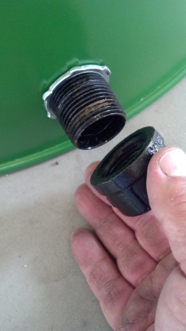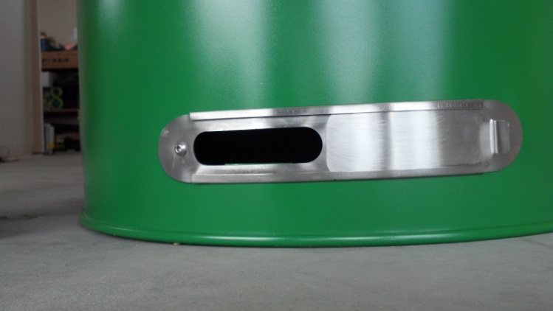

- Controlling temperature
Fire needs oxygen to burn. The more oxygen, the hotter the fire. Without oxygen (air) the fire will go out. The temperature of your smoker is controlled by the vents on the side or bottom. You will have either two ball valves or a sliding stainless steel vent door depending on the design of your smoker. Opening the vents further allows more air to the fire, raising the temperature, and conversely, closing the vents starves the fire of oxygen and the temperature will drop.

Ball Valves
Once the charcoal is lit and the smoker is approximately 50* below the target temperature, replace threaded cap on the rear of the UDS. When the temperature reaches 25* below the target, close one of the vents approximately 1/3 to 1/2 of the way. If you only have one riser, partially closing the bottom vent is preferable. Then as the temperature of the smoker approaches the target temp begin to “throttle” the temp with the remaining vent on the riser. With a little practice it is easy to dial the smoker in on an exact temperature with very few adjustments.

Sliding vent
Once the charcoal is lit and the smoker is approximately 50* below the target temperature, replace threaded cap on the rear of the UDS. When the temperature reaches 25* below the target, close the vent halfway. Then as the temperature of the smoker approaches the target temp begin to “throttle” the temp by opening or closing the vent as necessary. With a little practice it is easy to dial the smoker in on an exact temperature with very few adjustments.

- Continue to monitor the temperature of the smoker and make adjustments as necessary. When you first start controlling the temperature of the smoker, the lit charcoal will put off a whitish, acrid smoke due to being starved of oxygen. Do not add food at this point! One of the keywords of BBQ is “thin blue smoke”. Be patient and wait for the whitish smoke to go away and the smoke to turn “thin blue”. This can take a half hour or longer so pre-planning and patience is needed. Sometimes thin blue smoke can be almost impossible to see without a dark backdrop of some kind. Smoking your food with long durations of thin blue smoke will result in much better tasting food than if you allow the meat to come in contact with the acrid, white, strong-smelling smoke seen at startup.
- Once the white smoke has started to dissipate, open the lid and place the grates inside the smoker and place your food on the grates. Close the lid. Do this as quickly as possible to retain heat.
- Once the meat has been placed in the smoker and the lid is on, keep an eye on temperatures. Remember, by opening the lid you allowed more oxygen to the fire, so most likely the temperature will spike above your desired temperature for a short time. Avoid the temptation to make drastic changes to the valve settings. It should stabilize and come back down to near where it was set before. However, the cold meat will have some effect on the temperature of the smoker, so small adjustments may need to be made over the next half hour or so. The more meat you place in the smoker the hotter the fire you will need. For that reason you may at times actually find that you need to remove the threaded cap to maintain temperature. Note: The threaded cap air inlet and the lower ball valve will allow much more air to the fire than the ball valve on the riser, even though the openings are all the same size. This is due to the “chimney effect” of the riser. The purpose of the riser is simply to allow minor adjustments at waist level without stooping over.

- Inserting meat probes
There are two holes in the left side of the smoker to facilitate the use of remote meat probes to monitor the meat and/or smoker temperature. The holes are covered by a round magnet. Simply move a magnet, insert probe, and then place the magnet over the remaining hole to block airflow as much as possible. Usually two probe wires can be run through one hole.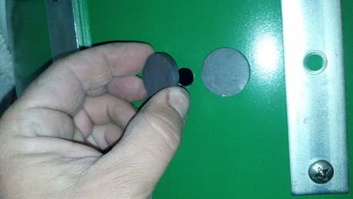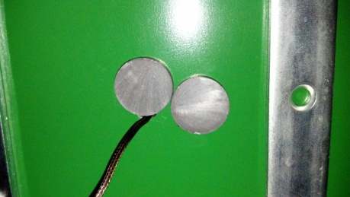

- Using the hanging rack
The optional hanging rack provides options for smoking a variety of different foods. By hanging large or odd-shaped items such as ribs or half chickens, the capacity of the smoker is greatly increased. Some folks claim that by hanging, the meat is stretched during cooking as opposed to shrinking up like it does on the grate, resulting in more tender, succulent barbecue. Whatever the reason, there is something magical about meat suspended above a smoking fire.
To use the hanging rack, remove both grates and place the rack on the top row of support bolts. Place the meat you are cooking on the stainless steel hooks, and hang them from the cross bars. If hanging ribs, place the hook between the second and third bone of the large end of the rack of ribs. The rack includes eight hooks. More hooks are available if needed.
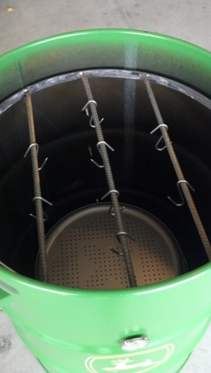

- Seasoning your smoker- It is a good idea to “season” your new smoker to burn off any oils or other materials leftover from building the smoker, and to give the inside a pleasant, smoky aroma. This will help prevent off flavors during your first cook.
- Rub the entire interior of the UDS and the cooking grates with vegetable oil, or spray with a cooking spray such as PAM.
- Light the smoker and add smoke wood as described above.
- Once the temperature has stabilized, add a few strips of bacon to the grates. If you do half a dozen or so you can enjoy a piece or two after an hour and a half.
- Run the smoker at around 250*-275* while seasoning. Plan on running the smoker all afternoon. This will give the smoker a nice baked-on coating of cooking oil / smoke and the extended time will allow you to learn a little about how to control the temperature of the unit before you risk a meal on it.
Note: The vent settings you set to maintain temps in an empty smoker will be quite different from the vent settings needed once it is loaded with cold meat.

- Shutting down the smoker – To shut down the smoker, simply close all the ball valves and wrap the chimney with aluminum foil to prevent airflow. The fire will eventually starve from lack of oxygen and go out. When you are ready to light the smoker again, simply bump the basket on the ground to shake out the ash, add fresh charcoal to the top, and light the smoker using the methods described above.

Tips on BBQ and cooking with a UDS
- The number one rule of BBQ – “If you’re lookin’, you ain’t a’cookin.” Keep the lid closed as much as possible! Smokers run at very low cooking temps, usually 225*-275*. If you are cooking a brisket or a Boston butt which needs to reach around 205* to be juicy and tender, and your cooker is running at 225*, that is only 20* higher than you are trying to heat your meat to. This is the reason it takes a long while for these cooks to finish, because with the cooker only a few degrees hotter than you are trying to get the meat temperature to, it takes a long, long time for that heat to permeate to the center of the meat. Opening the cooker will very quickly reduce the temperature to below the temperature you are trying to get your meat to, meaning essentially that the meat simply stops cooking until the smoker fully recovers its temperature, which can take 20 minutes or so sometimes. As a rule, only open the lid of your smoker if you are needing to tend to the meat, such as spritzing, glazing, or saucing, turning, wrapping in foil, taking meat temperature, etc.
- Smoke woods
- Chips or chunks – There are two different types of smoke woods that can be used in a charcoal smoker, chips and chunks. Most BBQ enthusiasts use chunks over chips. Chunks are available at many retail stores in small bags. Also, Home Depot has several varieties of chunks in larger bags. Chunks are preferable because they tend to smolder for a long while, giving a slow, steady smoke. Chips tend to burn off rather quickly, so if you choose to use chips make a ribbon of chips 2” wide or so that slowly spirals from the center of the charcoal basket to the outside edge. If you read online articles about BBQ, many so-called experts tell you to soak your chips or chunks in water. Do not do this! All it accomplishes is to cool down the fire and create steam. The wood will absorb very little moisture, and what little it does absorb quickly disappears as soon as it is placed on the coals. Also, start with less and if you want more smoke flavor add more smoke wood next time. It is easy to over-smoke food, making it bitter. Experiment and adjust to your liking.
- Wood varieties- Generally, use lighter flavored smoke for pork and poultry, and heavier flavored smoke woods for beef. There are many varieties that are used. Apple is a good lighter smoke for pork and poultry, hickory and oak produce medium smoke and are good general purpose woods that can be used for about anything, while mesquite is quite heavy flavored and is best on beef, although some people don’t care for mesquite at all. Other woods to try if you can get them are cherry, pecan, peach, alder, and maple.
- Self-cut woods – If you have a hardwood or fruit tree in your yard, feel free to use pruned branches. Cut the branches into small 2” chunks and let them cure until they are completely dry to prevent off-flavors. You can also pick up scraps from cabinet shops which can be cut into small chunks for smoking food. Only use hardwoods, preferably from fruit or nut-bearing trees. Soft woods have lignin and resins that are unpleasant to the taste.

- Thermometers
- Dome – Your dome thermometer, or in the case of the UDS, the one on the side, should only be used as a general reference. Temperatures will vary inside the smoker, and may be considerably hotter at the grate levels than is shown on the thermometer.
- Instant-read – It is important to have a decent instant-read meat probe thermometer to check the internal temperature of the meat. The best results in BBQ, especially in large cuts of meat, such as Boston butts or briskets, are always obtained by cooking by internal temperature of the meat, not by using a set time at a set temperature.
- Wireless – a wireless thermometer is very handy to have when cooking for long periods of time. These have a probe that is placed in the meat, and a transmitter sends the temperature to the receiver which is inside, allowing you to monitor the cook from inside. Some of the better wireless thermometers have dual probes. One lays on the grate beside the meat, and the other is inserted in the meat. This allows you to monitor both the smoker temp as well as the meat temp. In order to use a wireless probe in your UDS, you will need to drill a small hole in the side an inch or so below the lid to run the probe wires through.
- Note about meat temperature: When smoking large cuts, such as brisket or Boston butt, only use meat temperature to determine when the cut is nearly done. Every piece of meat finishes differently. Once the meat temp is getting close to done, begin to pay close attention to how it feels when you insert the probe. The probe will have some resistance, but you will know the meat is done when you suddenly insert the probe and it slides in like a hot knife through butter, with almost no resistance. At this point probe several spots in the meat and only take it out of the smoker when it probes tender everywhere.
- Controlling smoker temperature
- Make small adjustments to the vents. Moving the vents just a small amount will have an effect on the temperature.
- Be patient. Once you have adjusted the vents it will take a while for the temperature to stabilize. There is a learning curve to controlling temperatures, but once you get your smoker adjusted it will “settle in” to a certain temperature, and run there. Don’t check your temperatures and / or adjust your vents too often. Once you get the smoker lit and running at or near your target temperature, only check your temperatures every 20-30 minutes, making small adjustments as necessary.
- Don’t obsess over smoker temperatures. A lot of people get frustrated trying to keep their cooker at an exact temperature. If they are wishing to cook at 250* they will adjust the vents when the temp gets to 255*, and then again when it falls back to 245*. This is unnecessary and frustrating and takes all the leisurely fun out of BBQ. If you are hoping for 250* and it settles in at 260*, relax… it’ll be fine. Also, as coals light, burn, and then burn out, the temperature will fluctuate slightly. Avoid constantly adjusting the vents. The temperature will move up and down and few degrees, but it will remain much more stable if you just let the cooker do its job. Only adjust the vents if you are seeing a trend over a longer period of time, for example, if each time you check the smoker it is falling a few degrees.
- Ash will accumulate over time in the charcoal basket and on the burning coals themselves. This is usually more of a problem if you are using briquettes, as they tend to produce a lot more ash. If you find that the temperature will not climb even when you increase the vent openings, most likely there is ash coating the coals and limiting their ability to burn hot. With a UDS, carefully rocking the drum back and forth so that it thumps on the ground is often enough to shake the ash loose and allow the temperature to climb. You can also open the lid, remove the grates, and, using a welding glove or a hook of some sort, lift the charcoal basket out of the smoker and thump it on the ground a couple of times. Also, at this point you could also use a stick or some kind of tool to clean the ash out of the pan underneath the basket. Then place everything back inside the smoker and continue cooking.
- Wind blowing across the smoker will greatly affect temperatures. Not only does it cool the surface of the drum, robbing heat from the inside, the air currents blowing past the vents and the chimney can create a vacuum or pressure in the smoker that can cause temperatures to rise or fall. Try to set the smoker in a place that is out of the wind to avoid problems.
- The temperature of the smoker will always spike up whenever the lid is opened due to the introduction of oxygen. To help control this, plan ahead. 5-10 minutes before opening the lid, close the vents completely. Then, after you have closed the lid, leave the vents closed until the temperature is no longer rising before opening them up again to the exact setting you were using before. This will also help prevent a flare-up grease fire when the lid is open. When the lid is open, be observant of crackling coals / smoke / heat and close the lid if it feels like the fire is getting too hot and leave it closed until the temp comes back down.
- Using a water pan
On long cooks, a water pan can help retain moisture and also helps stabilize the temperature of the smoker. If you are smoking a brisket on the upper grate, place a large pan full of water on the lower grate. Be very careful not to spill water into the charcoal basket as it will extinguish your fire. If your smoker is tending to run hot, you can add cold water as the cook progresses. In cold weather, use hot water.
- How much charcoal to use
Always start with a full charcoal basket. That way you can be sure you won’t have to add charcoal in the middle of the cook. The basket holds enough charcoal to easily run 18-24 hours at 225-275 degrees. If you don’t have enough charcoal and run out, adding is a huge hassle. If you start with a full basket, whatever isn’t used can be extinguished and reused.

Other BBQ learning resources
- www.amazingribs.com – Meathead Goldwyn, Max Good, and Dr. Greg Blonder, food scientist, have turned amazingribs.com into a huge resource for beginners and experts alike. This site is an absolute gold mine for anyone who wishes to learn more about grilling and BBQ. There are dozens of reviews on all types of BBQ equipment, from thermometers to cookers themselves, pages of tips and techniques, information to help understand the science of BBQ and grilling, and a lot of recipes. Myths and old wives tales about cooking meat and various techniques are either proven or debunked in their experiments. (Searing steaks at high heat “seals in the juices”… False! What’s different about beer can chicken? Nothing!) There are sections on various cuts of meat, a whole section on hamburgers, advice for great steaks…..Yeah! You got it.
- www.bbq.about.com – Derrick Riches gives simple, down-to-earth instructions on how to grill and BBQ.
- www.barbecuebible.com – Steve Raichlen is one of the most well-known figures in the grilling world. His expertise is more in the area of higher temp grilling, as opposed to low and slow BBQ. He has written numerous popular books which you may have seen in bookstores, such as How to Grill and The Barbecue! Bible.
- www.bbqpitboys.com – Somehow these rednecks have managed to become the #1 most recognized name in BBQ. Their YouTube channel ranks in the top 10% of all channels. Their recipes are always interesting and are posted on their website, from breakfasts to burgers to briskets and everything in between.
Questions?
If there is anything you wonder about regarding the use of the smoker or BBQ in general, feel free to call me at (208) 539-4207, or email me at kunruh79@gmail.com. I don’t claim to know everything but if I can help you out I will. BBQ is a passion of mine and through the years I’ve gained a considerable amount of knowledge which I would like to share if it helps people learn to BBQ successfully. I want you to enjoy your drum smoker and hope that you use it often. I will even come to your house and show you how to use it, provided you supply me and my family with a good supper amongst the company of a few friends.
Good luck and happy smoking!

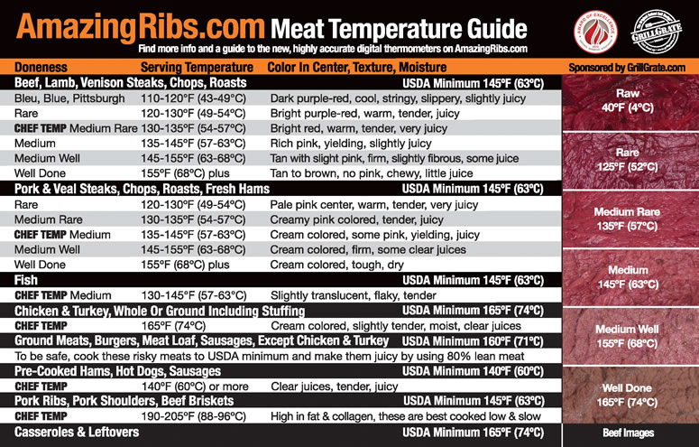

Boston Butt Basics (Pulled Pork)
A Boston butt is an ideal choice for the beginning BBQ pit master. This cut is from the shoulder (front leg) of a hog. A whole shoulder consists of the butt (top half) and picnic (bottom half). The same smoking principles apply to all three cuts of meat (i.e. shoulder, Boston butt, or picnic).
Or you can follow these basic instructions for cooking this popular cut of meat:
Cook the cut of your choice at 225-275*F for approximately 1.5 hours per pound until the internal temperature reaches 180*F for slicing or 195-205*F for pulled pork. Note: Cooking time can vary widely due to local conditions and the condition of the meat. Always cook to desired internal temperature. Use cooking time as a rough idea of the duration of the cook.
A Boston butt is a good choice for the beginner because it is much more forgiving when things don’t go as planned during a cook. It can withstand a broader range of temperatures than many other cuts of meat, due in part to the fat content. Due to melting fat, the meat doesn’t dry out as easily if temperature exceeds recommendation due to heat spikes.
The following is a set of basic instructions to prepare and smoke a Boston butt for pulled pork. Once you master these basics, then you’re set to explore the fascinating world of pork BBQ in all its variations.
Preparation & Supplies Needed: The day before the cook.
Boston Butt (NOT been injected with flavor enhancers - Read the labels.)
Plain yellow mustard
BBQ rub
Plastic Wrap
- Rinse the butt with cool water. Pat dry with paper towels.
- Apply a thin coating of yellow mustard to all surfaces. Rub it in well.
- Coat the meat with a heavy application of rub. Make sure all surfaces are well coated, rubbing it thoroughly into the flesh.
- Cover the butt with plastic wrap and refrigerate overnight.
Pit Preparation: Day of the cook
Set up your smoker in accordance with the applicable instructions for indirect cooking. While the principles are nearly the same, set up steps will vary depending on the fuel source and the style of cooker. The following applies to a charcoal fired offset. Make the necessary adjustments for propane, electric, or wood fires and for vertical smokers or when using a grill.
- Place a drip pan (disposable aluminum pan) under the grate, below where the butt will be placed. Add ½” of water to the pan. If using a temperature probe to monitor grate temperature, place it on the grate over the water pan.
- Use the Indirect Grilling Method to start your fire to bring your pit up to approximately 230*F. Add your choice of wood chunks.
- Oil the grate well.
- When you’ve reached cooking temperature, remove the Butt from the refrigerator. Add an additional application of rub to the fleshy portions of the butt. Rub it in well. Insert a probe thermometer to monitor internal temperature of the meat.
- Place the cold butt on the grates, over the water pan, and close the lid.
- Monitor the grate temperature, adjusting the intake vent as needed to maintain the range of 220-250*F. Additional fuel will be needed as the cook progresses.
Notes: Add additional wood chunks for the first 2-3 hours of the cook. Time depends on both your preferences for the amount of smoke flavor you want and the wood choice you’ve made. For a light smoked flavor, using hickory, quit adding wood after about 3 hours.
During the smoking of a butt, internal temperature will stop rising and may even drop a few degrees. This is called a plateau and generally happens around 160-170*F. This is normal. During this time the moisture in the meat begins to evaporate off, and the evaporative cooling effect will slow or stop the cook for up to several hours. Resist the temptation to add more fuel to speed up the process. Allowing the process to continue at its own pace will result in a better end product.
Basting is optional.
- If you are planning on sliced pork, remove the butt when it reaches an internal temperature of 180*F. If you are planning on pulled pork, remove the butt when the internal temperature reaches a minimum of 195*. Allowing the butt to reach an internal of 205-210*F, also results in a better end product.
- Remove the butt from the pit and place it in a clean disposable pan or other suitable container. Cover with foil. Cover that with a heavy bath towel and let it rest for at least a half hour. Recommended time is to let it rest for one hour or more. This allows time for the juices in the meat to redistribute throughout the meat. Premature cutting will result in moisture loss.
- After resting, prepare the meat for your choice of serving methods. For pulled pork, remove the skin and underlying fat layer. Either discard or place aside for another use. Separate the muscle groups, removing any excess fat. Tear the chunks of meat into bite sized pieces. Chop, if desired.
- Add your choice of BBQ sauce, depending on your choice of BBQ style. Serve additional sauce alongside for those who like extra sauce.

BBQ Ribs Basics
Mmmmmmmmm ribs!!! All animals have ribs but the two main types of ribs that weï¿½ll concentrate on in this article are BEEF AND PORK.
What types of Ribs are there?
PORK
Spare Ribs are cut from the front chest area (belly) and are meaty, rich in fat, and full of flavor. They are not as tender as loin back ribs but can be cooked to tender perfection. Full slabs (or racks) of ribs vary in size depending on the animal they came from. Smaller pigs may yield a slab weighing 3 pounds or less while older, more sizable sows might render 5+ pounders. Usually it’s recommended to choose ribs weighing less than 4 pounds because the quality of the meat is better from younger animals. Some consider the choicest of spare ribs to be slabs that weigh 3 pounds and down. Bones of spare ribs are somewhat big; one end has considerably larger bones than the other. These are referred to as the “large end” and “small end” when a slab is divided in half for serving.
Loin Back Ribs, also called baby back ribs (small loin backs), are smaller and cook faster than spares. The term “baby” does not mean the ribs came from an adolescent piglet, instead it refers to the smaller bones located near the backbone of the animal. Loin backs are not as meaty and are leaner than spares; thus their flavor is lighter. They range in size from 1.5 to 3 pounds and it is recommended to stick to slabs weighing 2 pounds and down for the best quality.
Danish Ribs originated in Sweden and are even smaller than baby backs. These ribs are reported to have less meat than baby backs and sometimes have a different flavor. They are usually 4” to 5” wide, about 15” long, and weigh around 1 to 1.5 pounds.
Country Style Ribs are not ribs at all but come from either the pork shoulder (aka Boston Butt) or loin area. This cut of meat is well marbled with fat and can be cooked similarly to spare ribs (i.e. 3-2-1) or grilled and is an excellent choice for kebabs.
Flat Bone / Button Ribs / Riblets are small, circular in shape, and flat, with varying amounts of meat. The kind you see at restaurants as ”All-You-Can-Eat”. The term riblets can also apply to just about any trimmings produced from cutting down a full slab.
What Should I Do to the Ribs Out of the Package?
Prepping ribs consists of four basic steps:
- Rinse the ribs thoroughly with cold water & blot dry with a paper towel.
- Remove the membrane, most butchers will remove it for you if asked.
- Remove excess fat like the pockets of fat between bones.
- Trim the slab to desired style.
Do I Need to Remove the Membrane? How?
However you decide to trim your slab of ribs (or not), it is highly recommended that you remove the membrane from the ribs before cooking. This will allow you to remove excess fat pockets under the membrane, the remaining fat to melt away better while cooking, smoke and spice flavors to permeate the underside of the meat, and it also makes it easier to eat when done. Removing the membrane can be a little tricky at first as it has a tendency to tear, but is not that difficult with a little practice. Work your finger, a butter knife or clean screwdriver under the membrane a few inches from the large end and work back towards the end until you free the end of the membrane loose. Using a paper towel to grasp the membrane, gently pull it off. Be sure to remove any remaining areas if it tears. Another technique for removal is to use a butter knife and wind the membrane up on it, as you would the lid on a sardine can when opening it, by rolling the knife.
Once the membrane is off, it’s time to decide if you’ll trim the ribs, and how. You can certainly cook the slab of ribs whole if you like. When you separate the bones for serving you’ll have extra long ribs. For those that prefer to trim, there is St. Louis style or Kansas City style.
What is St. Louis or Kansas City ribs?
Pork spare ribs can be prepared several ways. First, let’s identify the different parts of the slab. A whole slab will contain 11 to 14 rib bones and if not pre-trimmed will have the meat covered costal cartilage (also named ”brisket”) attached, that sometimes includes a portion of the sternum. The two sides of the slab are referred to as ”the meat side” and ”the bone side”. The meat side is self explanatory, the side on the top curve of the bone. Most folks consider this the top. The bottom side or bone side has a long meat flap also call the skirt, a membrane layer on the surface, and pockets of fat under the membrane.
Saint Louis Style Ribs
To trim the ribs, locate the ”knuckle” where the bone ends and the coastal cartilage meet and cut lengthwise along the joints separating the ribs from the tips (or brisket). This squares up the slab and makes it look nice. The tips can be the cook’s treat to nibble on, or used for pork tacos, enchiladas, chili meat, etc.
Kansas City Style Ribs
K.C. ribs are prepared the same as Saint Louis Style with one additional step, remove the skirt meat off the bone side. Be sure to cook it alongside the ribs as a reward for all your hard work.
What is a good serving size?
A full slab of spare ribs will serve 3 to 4 people when accompanied by a healthy serving of sides. However, if good ‘ole slow smoked, home cooked with love, barbecued ribs are left unattended for folks to serve up for themselves, they won’t last long. Baby back ribs are smaller and have less meat so figure 1 to 2 servings per slab depending on size (only 1 serving if they’re Danish).
BEEF
Beef ribs mainly come as short ribs or dinosaur ”beef back” bones. The membrane on beef ribs can be considerably tougher to remove than pork. In the same respect, it is also tougher to eat around so it should be removed.
Short Ribs contain 2 to 5 ribs of ribs 6 thru 10. They are frequently cut into individual pieces and can be ordered boneless.
Beef Back Ribs consist of 7 ribs that are 6 to 8 inches wide or cut in half to make 3-4 inch rib bones. They are a full-flavored rib that lends itself to spicy sauces from the traditional smoky barbecue sauce to a variety of ethnic flavors and seasonings.
On these ribs clings the same meat as you find in the finest prime rib roast. They are well marbled with fat and have very tender meat. Since the meat from these ribs can be sold in markets for a much higher price as ”prime rib,” many meat cutters remove as much meat as possible. Therefore, when purchasing ribs, especially beef, be on the lookout for ”shiners”. Exposed rib bones which should be covered with meat are referred to as shiners. If the meat is missing from the bone or is thinly covering the bone, chances are the bone will fall out of the slab when cooked, but if it doesn’t . . . who wants a rib with hardly any meat on it?
Should I Slather? What is Slather?
The decision to slathering is completely up to you. Let’s talk about what it is and what it does. Once you know more about slather you’ll be able to choose whether or not to use it. Slather is a thin coating, repeat, THIN coating of mustard, Worcestershire, honey, vinegar, hot sauce, olive oil, vegetable oil, or even barbecue sauce applied before cooking to act as a bonding agent or glue to help hold the dry rub on the meat. In other words, a dry rub will stick better to a wet surface. What does this mean? More rub equals more flavor. On thinner meats like ribs you don’t necessarily need a lot more flavor as the meat is thin, so the mass-to-surface area ratio is low. Simply put, most of the meat is in direct contact with the smoke and spice (unlike a thick brisket or Boston Butt). So if you want to kick it up a notch use slathers to adhere more rub. Some slathers, such as mustard, contribute little or no flavor to the final product because most of the flavor is “cooked out”.
Should I Marinate Ribs?
Most will tell you that marinating ribs is not necessary, but others will exclaim that the added flavor is worth it. Both are correct, wonderfully tender tasty ribs don’t have to be marinated but they can. Some common soaks range from plain old apple juice, to red-wine vinegar mixes, to more complex flavors involving a whiskey / bourbon base. Times to immerse the ribs range from a couple hours to overnight.
What is the 3-2-1 Method?
The 3-2-1 method refers to cooking times in hours and involves the use of foil. This technique is used for cooking pork spare ribs but can be adapted to baby backs or even beef ribs by adjusting times. Cooking temperature should be around 225* +/-.
The first number “3” refers to three hours in the smoker exposed to heat and smoke. The spices will have formed a good bark and the meat will look cooked but won’t be tender.
The second number “2” is the time ribs are wrapped in heavy duty foil (preferably extra heavy duty) and placed back into the smoker. A little apple juice, honey, barbecue sauce, or other flavors can be added to the pouch at this time if desired. The ribs will steam and braise in their own juices or added liquids during this phase and become very tender. The meat will shrink back from the bone a little. If the heat is too high you will get a product that resembles boiled ribs and the meat could shrink back as much as an inch or more.
The third number “1” is the last step where foil is removed and ribs go back into the smoker for an additional hour to firm up and dry out a little. During the last half hour of this phase some barbecue sauce or a glaze may be applied to the surface of the rubs for appearance and additional flavor.
By understanding what happens during each stage of the 3-2-1 cooking process you can adjust your results by varying the times. For a firmer textured meat allow the ribs to spend less time in the foil and more time in the open heat. Likewise, for more tender meat, ranging from ”fall off the bone” to mushy, leave the ribs in foil longer.
Baby backs will take less time to cook so change the numbers to 2-2-1 or even 2-1-1 to achieve similar results on these smaller ribs.
Do I wrap in foil or not?
That is the question! Do you have to foil ribs to cook them in a smoker? Absolutely not. Then why use foil at all? Using foil does several things, some of which you may or may not prefer.
Foiling can help speed the cooking process by braising & steaming which cuts down overall cooking times and fuel costs. It also helps the novice produce a more consistent product. Using foil limits the amount of time food is exposed to smoke and can be use to control taste by preventing over smoking lighter flavored meats with heavier flavored woods. Limiting exposure to smoke and heat can also be used to control surface color and keep food from becoming dark or burnt looking.
So if you’d like to cook ribs and choose not to foil, just add an hour or two to the cooking time and you’ll still enjoy tender, juicy, flavorful ribs.
Can I use anything other than foil?
Some barbecue chefs use plastic wrap in place of foil. Some precautions must be observed when using plastic wrap. Ensure it is food grade and that its melting point is higher than cooking temperatures. Some plastics contain dyes or chemicals that are harmful if consumed and heat can easily transfer these compounds to food. Some plastic products can melt at very low temperatures. So, when choosing a plastic wrap you must select one that will take the heat at which you are cooking for extended times, plus the heat of any temperature spikes that occur. Also keep in mind that the firebox end of an offset cooker is considerably hotter than the exhaust stack end and will see higher temperature spikes.
Plastic wrap is not at all suited for indirect grilling applications.
Plastic wrap is also an excellent choice for wrapping meats after they are cooked for placing them into a pre-warmed cooler to rest or hold.
I have limited cooking space. How can I cook more ribs?
Increasing cooking capacity in a small smoker can be accomplished several ways. Probably the most commonly used way for getting more ribs per square inch is placing them in a rib rack. A rack is usually made from sheet metal or wire and holds the ribs vertically standing the bones up & down while allowing heat and smoke to pass over all surfaces of the meat. Example: “|||||” (as viewed from the side). Most racks will accommodate 3 to 5 slabs of ribs while only taking up grate space of 1 or 2 slabs if they were laid down.
If you don’t own a rib rack, ribs can also be stood up and leaned against each other in groups of two or three. Examples: “ /\” or “/|\” (as viewed from the ends). You can run skewers through the tops of the slabs to stabilize the free standing ribs and space the tops out from each other a little.
If there is not enough room to stretch out a full slab of ribs without needing to halve them, as in a Weber Smoky Mountain (WSM) or a Great Outdoors Smoky Mountain (GOSM) 16” model you can roll them up. The slab is coiled up until the ends meet and then pinned together with a skewer to form a doughnut shape. Example: “O” (as viewed from the top).
Yet another clever way to pack the maximum amount of ribs possible into your smoker is to stack them. Example: “nnn” (as viewed from the end). The “n” represents the arc of the bone with the bone ends pointing down (membrane side) as opposed to “u” with the bone ends up. Several slabs of ribs can be stacked on top of each other. The catch is, the ribs on top and ribs on the bottom of the stack have only one side directly exposed to heat and smoke, so this adds to the amount of time it takes to cook the ribs. This also requires that the ribs be rotated to ensure each slab gets exposed to smoke and they all cook evenly. Rotating requires you to, for example, remove the slab from the bottom of the stack and place it on top. During the next rotation, the slab from the bottom is moved on top of the previous one and so on. This exposes both sides of each slab after a complete rotation of all the ribs. Rotating should be planned out so that all the ribs go through a complete cycle once or twice. Example: 4 slabs of ribs stacked, cook for 8 hours, rotate once an hour, each slab is cycled through the rotation twice and all slabs get equal exposure.
You can also criss-cross the ribs laying two slabs east-west parallel and near each other, then lay two more slabs on top of them running north-south, similar to building Lincoln Logs as most of us did when we were children. The criss-cross method is reported to increase capacity without having to rotate slabs and the ribs cook in approximately the same amount of time as using a rack. You can stack them as high as your smoker can handle without concern of the ribs falling over.
There’s nothing stopping you from getting creative and stacking additional wire racks on top of each other and using something as simple as children’s wooden building blocks or bricks for spacers. There’s probably a solution somewhere around your house, all you have to do is recognize and adapt.
What are Ways to Cook Ribs?
Ribs can be spun on a rotisserie, barbecued Low-N-Slow, grilled direct or indirect, boiled, broiled, or braised. Some methods work MUCH better than others. This article is mainly directed towards low and slow smoking but cooking them on the grill is also fantastic.
Beef ribs can be grilled like steaks. After all, they harbor the same meat as a rib steak. Some even cook them to the same doneness as they would a steak. Short ribs are commonly grilled with Asian flavors.
Baby back or loin back ribs also grill and rotisserie cook well because they are more tender than spare ribs and cook quickly.
Spares are best when slow smoked or grilled indirectly for a longer period of time.
When Do I Mop/Spray?
Most ribs are marbled with enough fat to keep themselves moist while cooking, but some people like to moisten them while they are cooking. It’s a fact that heat conducts better through moist matter than dry matter so there is some benefit to mopping or spraying.
On the other hand, there are pitfalls to the process. Running liquid or moving a mop over the meat’s surface can easily wash away your dry rub if it has not formed a crust (bark), so let the meat cook for a couple of hours prior to application. If you are using a mop, dab the mop in an up & down motion and not back & forth to prevent removing the spices from the meat. Additionally, each time the door or lid is opened heat escapes from the cooker. Dropped temperatures from heat loss will extend cooking times and require more fuel to bring temperatures back up.
If you are using the 3-2-1 method to cook your ribs you could mop or spray at the 2 hour mark and then add a little liquid to the foil and nothing more would be needed. But that one spritz at 2 hours isn’t really going to make much difference.
If cooking without foil, or not wrapping, then you could elect to mop or spray once an hour (skipping the first hour mark to allow the bark to form). However, to reduce the number of times the cooker is opened you can moisten on the halves. By halves, it means to divide the remaining cooking time in half.
Examples:
On an 8 hour cook, spray at the 4 hour mark, 6 hour mark, and 7 hour mark.
On a 7 hour cook, spray at the 3.5 hour mark, 4.75 hour mark, and 6 hour mark.
On a 6 hour cook, spray at the 3 hour mark, 4.5 hour mark, and 5.25 hour mark (optional).
This will reduce the number of times the cooker is opened thus saving time and fuel without lessening the quality of your ribs.
Again, you’ll find folks that say, ”If you’re lookin’, you’re not cookin’.” And they’ll tell you to skip mopping & spraying all together and leave the door closed until it’s done. However, if you’re not experienced enough to know what’s happening inside your cooker without looking on occasion then you could easily over cook the ribs. Only follow this philosophy if you’re proficient.
When Do I Glaze?
Most glazes and sauces contain a fair amount of sugar and can burn if exposed to too high of heat for too long. To keep from burning, it is best to wait until near the end of the cooking process to apply these products. Most recommend application around 20 to 30 minutes prior to removing from the cooker. This isn’t long enough for sugars to burn in a low & slow environment but it is ample time to allow the glaze or sauce to “set,” meaning it will thicken or dry enough to stick to the meat and form a glossy appearance which is pleasing to the eye and tongue. If grilling you would lower the time to no longer than 10 to 15 minutes before finishing.
How Can I Tell When the Ribs are Done?
It is very easy to tell when ribs are done, here a few ways;
A good visual sign the ribs are done or getting real close to being done is when the meat shrinks back from the end of the rib to expose about 1/4 inch of the bone. If you’re using foil the shrinkage could be a little more, if not it could be less.
One way to test for doneness is take a pair of tongs and pick up the slab by the middle, if the slab is limp, flexes easily and the meat wants to tear away from the bone consider it done.
Another way is to grab two bones near the middle of the slab and give a tug; they’re done if the meat starts to pull easily away from the bones.
Finally, take a toothpick and poke into the meat between the bones, it should slide in and out with very little to no resistance.
How Should I Cut the Ribs to Serve Them?
There are a few different ways to present your ribs for consumption. You can simply divide the slab into serving sizes and let your guests do the rest or cut each rib off into separate pieces. An easy way to tell where to cut the meat of a rib without hitting a bone is to look for the exposed ends of the bones and notice the hump of meat that runs between them. Sometimes the bones are angled and a perpendicular cut would slice into a bone. Angle your knife to align with the ridge of the meat and you’ll get a clean cut.
To be a gracious host or to score a little higher at competitions there is a technique called ”the California Cut” or competition cut. Find the bone and cut as closely to it as possible, leaving all the meat on the other bone. Then leave all the meat on the opposite side on the same bone and cut the next bone off as close as possible. This leaves a generous amount of meat on both sides of some bones and practically none on the others so you only have about 6 to 7 ribs per slab for serving.
Example: B=bone, M=meat, |=cut here ”MB| MBM |B| MBM |B| MBM |B| MBM |B| MBM |B| MBM”
Baby back ribs and Danish ribs are probably most impressive served as whole slabs.
Should I Serve Ribs Dry or Wet?
Yes, you should at least try both.
Rib Industry Terms
Baby Backs - A term used to describe the size of a Loin Back Rib. Unfortunately, many times the term is applied to any size Loin Back Rib. A true Baby Back Rib is 1 3/4 lb. or lighter.
Reduced - A rib that has had a riblet removed or any meat removed so the weight of rib falls into a lighter weight range.
Cut Downs - Refers to cutting down a rib from one or both sides of the slab in order to drop the slab into a lighter weight range. This is usually seen more with Loin Back Ribs. When a slab is longer than usual and the bone has very little curve, this is a sign of a cut down.
Cheater Slab - A nine bone slab of ribs.
Shiner - Ribs that have meat scraped from the top side of the rib, exposing the bone. When there is too much bone exposed, the bones will actually fall out during the cooking process. This will affect portioning, which in turn raises the plate cost.
Red Bone - When removing the brisket bone from the spare rib, it is common to cut into the actual bone on the flat bone (wide bone) end of the spare rib. Normal would be up to three Red bones. If there are more than three Red Bones, there is a good chance the St. Louis cut is a forced cut and not a natural cut through the cartilage.
Feather Bones - Smallest bones on the Spare Rib and Loin Back, located on the ham end on the hog. They generally will have more of a curve, and in some cases, actually are more of a cartilage.
Flatbone - On the Spare Rib and St. Louis Rib, this is the wide bone on the shoulder end of the loin. The Loin Back does not have a true flat bone but the heavy short bone on a Loin Back is also off the shoulder end of the loin.
Skirt Meat - BBQ Tender - The flap of meat found on the inside of the Spare Rib. It has a tendency to dry out during cooking and if the outside edge is not trimmed off, it can be very chewy. Many BBQers remove the skirt and put it into chopped BBQ.
Rib Membrane (Skin) - Both the Loin Back and the Spare Rib have a skin on their interior. This skin is heaviest at the back bone and becomes very fine at the belly end. The membrane's density has much to do with the age and size of the animal.
Many Quers want the skin peeled off all Loin Backs prior to cooking. Others will rasp/score the rib after cooking prior to finishing on the grill and still others feel that with light size Loin Backs, the high temperature of a broiler will sear the membrane off. (Large Loin Backs 2 lbs and up should always be skinned as they are from older and larger hogs.
Spare Ribs and St. Louis Ribs from (smaller) Butcher Hogs have very light membrane and when the skirt is removed, the heaviest portion of the membrane is also removed.

Beef Brisket Basics
Introduction
The intent of this article is not to cover recipes, but to explore the process of how to cook a brisket and to help familiarize you with some techniques, pitfalls, and theory involved. Don’t think of this as the final word in how to cook brisket, but a good place to get started your first time out. Everyone’s equipment is different and folk’s preferences vary as well, so the grain-of-salt philosophy applies when reading this opinionated advice. This article is quite long. Hopefully it won’t take you as long to read as it does to cook a brisket. Briskets aren’t as difficult to cook as the length of the article first makes it appear to be, so relax and don’t sweat it.
Before the big cook
A few things that you need to determine right out of the shoot is what type of brisket you want to cook, how much you’ll need and how long it will take to cook it. Keeping a log during long cooks will help you remember details for the next cookout, which can prevent you from repeating mistakes and failures, while increasing your odds of recreating successes and fine-tuning improvements.
What is a brisket?
First, let’s discuss the anatomy of a brisket. A brisket comes from the lower part of the beef in the “chest” region between and just behind the front legs. A couple of commonly sold cuts of brisket are “whole” also called “whole packer” which include the “flat”, “point” and “fat cap”, or you can purchase the flat only. On occasion you may be able to find points sold separately. Some folks confuse the term “deckle” with the point of a brisket but it is actually the muscle and fat that connects the brisket to the rib cage. You’ll find many references on the Internet that simply confuse the issue even further. IMPS defines the brisket cut sold to consumers as: *****All bones and cartilage shall be removed. The deckle (hard fat and intercostal meat on the inside surface) shall be removed at the natural seam exposing the lean surface of the deep pectoral muscle. The inside lean surface shall be trimmed practically free of fat. ***** Therefore when you buy a brisket at the store, most or all of the deckle has been removed and most butchers will also remove it unless requested to leave it.
Should I cook a packer or a flat?
A whole brisket will take longer to cook than just the flat. So why bother with a whole brisket? The point contains a good amount of marbled fat, which keeps it tender and moist while cooking. And the fat cap on a whole brisket is usually not trimmed off as much as a flat’s fat cap. In fact, the fat cap is totally missing from some flats, which makes them less suitable for low-n-slow cooking unless a fatty layer is added back such as a layer of bacon on top. The fat doesn’t “add” moisture to a brisket as much as it prevents moisture loss while cooking. Some BBQ competition chefs choose to cook brisket flats so they don’t have to stay up all night tending the fire. A flat can be started early in the morning and be finished by mid-afternoon.
How can I tell if it’s a good brisket?
When selecting the brisket at the store the first thing to check (beside price & weight) is the “sell by” date. Always buy the freshest meat. Then there are a few things folks check for, like a nice layer of soft, white fat. Hard, yellow fat is a sign that the brisket came from an older animal or the animal had a poor diet. Also look for fat that is marbled throughout the meat and not just in one area. Another tip for selection is to flex the brisket. The meat that bends tip-to-tip easily is a better choice for tender brisket than those that bend very little. Look for a brisket that has an even thickness across the flat. Those that taper to a thin end will not cook as evenly so that the thin end will overcook.
There is some controversy as to whether the left brisket or the right is more tender due to the effort it takes for an animal laying down and getting up while repeatedly using the same side to perform the majority of the lifting. Searching the Internet you’ll find some that believe this to be true while it seems the majority believe it to be lore told at a BBQ competition to get others to stop asking “What’s your secret?”
How much brisket should I cook?
How many times has this question been asked when cooking for a large crowd? The answer can vary as it depends on the type of eaters you have invited. Families with small children or elders will consume less food than college buddies watching the big game. Men tend to eat more than women and vegetarians eat less meat in general than others. So consider whom you are cooking for and adjust accordingly.
As a rule of thumb, estimate 1 pound of meat (uncooked weight) per adult guest and 1/2 pound per child. Sounds like a lot of meat doesn’t it? Consider loss. When you trim fat or gristle, that is loss that will not be eaten. Also as meat cooks it loses moisture by evaporation and fat renders & drips away; more loss. If you have a picky eater or someone watching their diet, chances are they will not eat the fat that remains no matter how good it smells. Other meats having bone, the bone must be counted as loss when figuring amounts. After it all boils down, you can figure anywhere from 40-60% product loss from the retail sale to the dinner plate, meaning, that if you bought 16 oz. of meat per person you are now serving the +/- 6 to 9 ounces, which is a recommended serving. You can save a little money by serving smaller portions, but to ensure everyone gets something to eat you will need a person serving the meat that can ration it out so that you don’t run out of food before everyone is served. To be a gracious host, cook a little extra to allow for seconds or a doggie bag.
How long will brisket take to cook?
Briskets are like snowflakes! What? No two briskets are exactly the same. Chicken & turkey can be estimated very closely with a “minutes per pound” ratio at a certain temperature, but brisket varies greatly. Let’s say for simplicity’s sake you can estimate 1.5 to 2 hours a pound. A 12-pound brisket can be done in 12 hours during one cookout and the next time a brisket weighing the same could take 22 hours. Why??? There are many variables that contribute to differences; the breed of the animal, its diet, the amount of exercise the muscle had, age of the animal, etc, etc, etc. This will determine the density of the muscle tissue and the amount of fat that is marbled into it. Even the type of cooking equipment used, the chef’s experience level at keeping a constant temperature on that equipment and the weather are all factors in how long the cooking session will be. So how could anyone possibly guess?
Good briskets take time to cook but the time varies so how do you tell when it’s done? There are a few methods that cook’s use. One of the simplest ways for a novice to tell when a brisket is done is checking it with a thermometer. Most briskets that are tough and dry were simply NOT cooked long enough. That sounds contradictory to all that makes sense but you’ll find out why when we talk about the plateau stage.
Most briskets will be done around 190* to 205*, however if you buy a good “choice” grade brisket it could be tender and juicy around 180* to 185*. We’ll cover testing for doneness later, after we’ve cooked the brisket.
To roughly estimate how long it will take to get a brisket to the dinner table, let’s work backwards…
Beef needs to rest after it is cooked so the juices can redistribute throughout the meat before cutting. A brisket should rest for no less than 30 minute on a counter or 2 to 4 hours in a pre-warmed ice chest. So let’s call it a 2-hour rest.
Cooking time is “ r o u g h l y “ 1 to 2 hours a pound. Let’s say most briskets weigh between 12 and 15 pounds. Most cooks run their smokers between 220* and 260*, grills usually run higher temperatures than smokers but should be kept low, not to exceed 300* if at all possible (read about the plateau to see why). So let’s guess 18 hours cooking time (which WILL vary).
If cooking equipment is allowed to come up to temperature before the meat goes in, then allow time for this, plus time to get the fire going. Some prefer to put cold meat in a cold smoker under the belief that the longer the meat spends exposed to smoke while it remains cold deepens the smoke ring (more to follow). An hour needs to be tagged on to get everything going.
So for an average cook, for an average brisket, on an average day, we can guesstimate about 23 hours prior to eating, it’s time to get things started. So if you’re planning brisket for dinner, start it just after dinner the day before and you won’t need to rush anything. (Disclaimer: Your mileage may (WILL) vary!)
Can a brisket be aged?
It is not uncommon to age beef, especially of the steak variety. Aging intensifies the beef flavor and tenderizes the meat. But do people really age brisket? There are several folks that “wet age” brisket for as long as 3 to 4 weeks. The brisket is kept sealed in its cryovac packaging in a controlled refrigerated environment between 34* to 38*. This means that it shouldn’t be kept in a fridge that is opened several times a day. Since the meat doesn’t dry using this method there is no concentration of flavor but the brisket should be more tender when done. A word of caution, aging meat allows bacteria to do their thing, so if conditions are not controlled properly the meat will spoil and not be fit to eat.
How much fat should I trim?
There are a few different schools of thought as to trim or not. Many cooks will trim the fat down to about ¼ inch and remove any hard pockets of fat while many others choose not to trim the fat at all. Both methods render a good brisket in the end. Some folks that have trimmed nearly all the fat before cooking usually report a dry tough brisket. This is most likely a direct result of removing the fat which is a protective barrier which shields the meat from the heat and reduces vaporization of the meat’s natural juices. Although there is some debate over whether the fat cap adds moisture to the brisket, only bastes the outside, or just protects it from the heat, this is sure, it helps keep the brisket moist.
If you wish to remove the fat for a low-fat or reduced calorie meal, it may be better to trim the layer down to 1/4 inch or so before cooking and remove the rest after the brisket has finished resting. The layer of fat can be easily removed in one fell swoop by running your hand (while wearing a PVC glove or similar) across the fat cap like a squeegee to scrape it off or you can carefully trim each slice after cutting it.
What is a slather? Should I slather?
A slather is basically a thin (emphasis THIN) layer of moist substance applied to the meat before the rub to help the rub adhere to the surface of the meat. Once you rinse the meat to removed possible contaminates and pat it dry and then try to apply dry rub to the meat, much of the dry rub will fall away onto the counter top (or other preparation surface) instead of staying on the meat. A slather smeared onto the meat helps the rub stick to it; therefore there is less rub wasted and more flavor in the final product. Different substances that can be used for slather are Worcestershire sauce, mustard, mayonnaise (or salad dressing), BBQ sauce, hot sauce, etc… Don’t be too concerned about the slather “flavoring” the final product. Used sparingly most slathers cannot be detected at the dinner table, except that there is more flavor from the extra rub that stayed on the meat. A lot of folks express concern about mustard tainting their BBQ but there is no detectable flavor from it after it’s cooked, when applied thinly. Try it. You’ll like the results.
When should I rub?
Some meats take on flavor quicker and easier than others. Chicken, fish, steak, and other thin or small cuts of meat can be seasoned 30 minutes to an hour or less before cooking. A brisket can also be seasoned just before placing in a smoker or on the grill to cook but it will benefit from a longer marinating session. A majority would agree that applying the rub the day before is perfectly acceptable. Some retail stores pre-marinate their meat before selling. This is becoming ever more popular. Acids will break down the meat fibers and salts will draw moisture out of the meat. Both will have an unwanted result on your meal if left on too long. This is why some folks, mainly do-it-yourselfers, don’t buy the pre-marinated meats. But how long is too long? On a large cut of meat like brisket it’s not recommended to rub more than a day ahead because of the salt content of most rubs. If you are using a no-salt rub then longer times shouldn’t be a problem.
During the big cook
You want to determine which way is up, avoid playing peek-a-boo, understand what’s taking so long, and be able to judge when things are ready. It is strongly recommended that you use a meat thermometer, like a wired remote probe or instant-read, to monitor the brisket’s temperature while it is cooking, until you gain experience enough to judge doneness using other methods.
What is a smoke ring and where can I get one?
A smoke ring is the pinkish to red layer of coloring normally around 1/4” deep under the surface of the meat that is caused by a chemical reaction between nitrogen dioxide (nitrites and nitrates) and myoglobin in the meat. This chemical reaction ceases to take place once the meat’s temperature rises to around 140* and will not develop any further during the cooking process. This is not to be confused with meat not taking on any more smoke flavor after the 140 degree mark as the meat will continue to collect smoke as long as it is exposed to it. The smoke ring is coloration only and does not contribute to the flavor of the meat. Some believe putting a cold brisket in the smoker yields a better smoke ring because it remains exposed to smoke for a longer period while below the 140* mark.
Artificial smoke rings can be chemically produced using dry curing, pickling and tenderizing products that contain nitrates or nitrites. These products can be applied to the exterior surface of the meat or injected. Take corned beef and pastrami, for example. These products are pink in color all the way through. Controlled exposure will give a smoke rink effect. Many BBQ competition cooks and judges say that they can spot one of these “fake” smoke rings a mile away stating that the color is usually lighter, less even, and the edge where the color stops is not as well defined.
In most BBQ competitions the color, depth, appearance or lack of a smoke ring does not count towards points. Even though judges are told to disregard it for scoring, appearance is one of the categories for scoring. When a human being sees that attractive coloring of the meat and there is a close decision between two entries, which do you think would win, with or without?
Should I put the brisket in cold or room temperature?
This is a matter of personal preference. While some say placing the brisket in cold produces the coveted beautiful smoke ring, a cold brisket also drops the pit temperature. So if trying to achieve a picture perfect slice of meat is your desire then by all means give it a try. But this will use more fuel, not much more if you’re only cooking one piece of meat. When cooking dozens of whole briskets for the masses the amount of fuel may add up enough to matter, so there’s a trade off. If you let the meat warm prior to placing in the smoker always keep food safety times and temperatures in mind. The Food and Drug Administration recommends keeping meats in the danger zone no longer than 4 hours total. The danger zone is considered temperature ranging between 40*F and 140*F. Once the meat is out of cold storage the clock is ticking. This includes transportation, preparation, and time spent in the cooker rising to 140*. So if the meat is on the counter 30 minutes to an hour to warm prior to cooking, that’s time off the 4-hour time frame.
Can I still smoke a brisket if I don’t own a smoker?
The short answer is most definitely. There are great, illustrated instructions on how to set up your grill, gas or charcoal, for indirect cooking in Steven Raichlen’s book, “How to Grill,” in the front of the book on pages 6 through 27. When using a small grill the fire goes on one side and the food on the opposite side. But when using a larger grill, a small fire is banked to each side of the grill while the food is centered between the two mounds of coals. Grills place the fire in a closer proximity to the food than traditional dedicated smokers and the temperatures can run a little hotter and fluctuate greater. Extra attention needs to be given to fire management when smoking on a grill. Since temperatures can be higher than the standard 225* to 250* you would expect to find in a smoker and spikes can happen quickly, more frequent monitoring of conditions will help prevent disaster. Also, opening the lid needs to be kept to a minimum, so whenever the lid needs to be opened you’ll want to have everything needed to replenish the fire, pre-soaked wood chips, baste-mop-spray, foil, and tools staged and ready for use to complete the task as quickly and efficiently as possible in order to prevent excessive heat loss. On a charcoal grill wood chunks or wood chips can be tossed directly into the fire to provide smoke. On a gas setup you will most likely wish to avoid getting ashes all over the inside grill, as cleanup would be a little difficult. Wood chips are placed in a cast iron smoker box that can be positioned in or near the flames of a burner being used to heat the unit. If the wood chips are not providing enough smoke the move the box closer to the heat, likewise if the chips ignite and burn up the box should be moved away from the burner a bit. Limiting the amount of oxygen to the wood will also prevent them from catching fire. You can also make a pouch out of aluminum foil (preferably extra heavy duty foil) and wrap the wood chips tightly in a double-layer as illustrated in “How to Grill” pages 17 & 18.
Should I marinate or inject?
Traditional marinades wouldn’t penetrate very deep into the thick muscle of a brisket unless it sits for several days. And there are injector solutions available for briskets. While some folks have used injections and mention an addition of flavor to the meat they also report that the meat can be discolored in the areas that were injected if the solution wasn’t evenly distributed.
What is the best cooking temperature?
The most common cooking temperature for brisket is in the neighborhood of 225* to 250* in a smoker. Some people prefer to cook at lower temperatures like 210* and others have said why waste all that time if I can cook it and 325* and finish it several hours quicker. Some competition pit masters these days are cooking their briskets at 275*. It is a general consensus that brisket should be cooked Low-N-Slow for the best product. A brisket is a tough ornery cut of beef that needs to be cooked for a long time to break down the fibers in the muscle tissue to make it tender. If it is cooked at higher temperatures the brisket will cook faster and if it isn’t a high grade of Choice or better then there is a good chance the meat will be tough and dry when served to eat.
What type of wood goes with brisket?
This is another area of personal preference. Different woods have distinctive flavors. Brisket is commonly cooked over a mesquite fire. However, for some this wood has a very strong flavor. There are even known cases of food allergies to mesquite. Other popular woods for brisket include pecan and oak. But folks use woods such as peach, apple, cherry, etc. to cook brisket with equal success. Fruit woods can also be blended with nut woods for a mellower, sweeter version of the more traditional flavors. In the end two factors play a big role in the selection of wood used, availability and personal taste. So try different woods and see which one suits you best.
If you are sensitive to heavier flavored woods like hickory and mesquite and the smoke taste is too strong for your liking, wrapping the brisket in foil or even a paper bag once the desired level of smoke is achieved will reduce exposure to smoke. Take care that the paper bag is not exposed to direct heat or flames.
Should I cook brisket in a foil pan?
Brisket can be cooked in a foil pan but most pit masters don’t use one. Some folks who cooked brisket in a pan have said that the bottom of the brisket reminded them more of pot roast than how a brisket should taste, while some say they can produce fantastic brisket using this method. Others express concern as to whether you could get a proper smoke ring and smoke flavor on the bottom of the meat. One thing that can be done to help is to place a wire rack in the bottom of the pan to elevate the brisket above the pool of juices to prevent it from braising while it cooks. This would also allow for a little airflow underneath yet keep the brisket in close proximity to the moisture. Another option is to put the pan below the food grate directly under the brisket to function as a drip pan.
Should I cook brisket fat side up or down?
A brisket can be cooked either fat side up or with the fat down. A couple of major factors in determining which way the fat belongs is “personal preference” or the type of equipment it is being cooked on.
Nearly as heated a debate as a Propane or Purist (charcoal, wood, lump) fire is the topic of fat up or down.
Some believe that if the fat is up it will melt and baste the meat during the cook helping to keep the exterior moist. Some have said that the fat melts into the meat making it moist and tender, however, recent explanation of the science of a brisket states that the meat is not porous enough to allow fats to soak in, instead it is the internal marbled fats and connective tissue that break down to do this.
Many barbecue competitors will tell you to cook the brisket fat side down. They have a pretty good reason for this. If it is cooked fat side up the surface of the meat comes in contact with the food grates and the bark is disturbed and even scraped off or it sticks to the grates. This is extremely undesirable when turning in your product to be judged. Cooking with the fat down allows a nice beautiful bark to form, preserving all the flavor of the smoke and spices.
Now if you want to determine the fat’s positioning according to what type of equipment you own, then place it according to where your fire is located. If the fire is located underneath the cooking area, as with a vertical smoker or a grill, then you may wish to cook with the fat side down. Just like on whales and seals in the great white North, fat is an insulating layer that can protect from extreme temperatures. With the fire below and the fat position down so that it’s between the heat and the meat, it can help protect the brisket from direct exposure to the fire’s radiating heat and from possible temperature spikes. If you have an offset smoker and the fire is to the side, positioning is totally up to you.
Should I rotate or flip the brisket during cooking?
If you have a smaller offset smoker where the pit is always hotter on the firebox end and the exhaust stack end is cooler then it is a very good idea to rotate the brisket. Rotating the brisket under these conditions will help promote more even cooking. However, since the point end (if cooking a whole brisket) is thicker and contains more marbled fat, it will need to face the fire for approximately 2/3 of the time.
Flipping is not necessary to produce great brisket but there are pit masters that swear by it. In fact one chef is known for removing his brisket from the pit, submersing it completely in marinade (as opposed to mopping or spraying) and then placing it back into the smoker on its other side. Some who do flip recommend doing so on the “halves”. Example: During a 20 hour cook; flip at 10 hours (half way into the cook), 15 hours (half the time remaining), and at the 17-1/2 to 18 hour mark.
Rotating can work better with offsets and flipping is optional depending on your opinion.
How often should the cooker be opened?
Truthfully … as little as possible! Every time the lid is opened you are adding to the time and fuel it takes to cook your food. When you open to peek, take a picture, mop or spray, flip or rotate, add fuel or smoke wood, add water (pre-heated hot water by the way), check the meat’s temperature, wrap in foil, etcetera, etcetera, etcetera, (see how many excuses there are) you let out precious heat. The smoker can take anywhere from 5 to even 20 minutes to recover its temperature after being opened, depending on door size, climate conditions and duration. So it is very important to resist the temptation to open the smoker. Some say do this or that hourly, and as mentioned above others recommend performing routine maintenance on the halves. But perhaps the best advice is, the less the better.
Does a brisket need to be mopped?
You can baste, mop, spray or even dip a brisket to keep it moist during cooking. If you do baste, mop, spray or dip, don’t do it for the first couple of hours. The reason for waiting is to allow the dry rub to dry out, set, and form a bark. Otherwise if you start off applying liquids to the surface right away you’ll end up washing all those good flavors off your meat. Science says that a moist surface will conduct heat better than a dry surface. Therefore, if you keep the exterior of a brisket wet while it’s cooking it should cook quicker. But there is a trade-off because opening the smoker slows the cooking process. Once again some recommend applying liquids hourly while other will tell you to only do it on the halves. You can still attain a moist tender brisket even without mopping if it’s cooked low-n-slow over a long period of time.
What is a plateau?
A brisket will go through a noticeable temperature plateau while cooking. This is normal and can last a long, long time. Somewhere around 160-165* the temperature can level off or even drop in the brisket. Some say that this is because the process of melting & breaking down connective tissue, sinew, collagen, and fat begins and that it consumes a lot of energy in doing so. However, more recently Dr. Greg Blonder with amazingribs.com fairly convincingly debunked that theory with a series of experiments. His claim is that the plateau, or “stall” as some refer to it, is caused by the evaporative cooling effect, similar to the way your body is cooled by sweating. According to him, the fact that fat renders at 160*-165* is coincidental with the fact that this is the temperature at which briskets usually plateau. No matter what causes it, it is a fact that a brisket can sit there for 1 hour or even stall out for 5 to 6 hours; the time will vary from one piece of meat to the next. Be patient during this period and let the brisket take its time without trying to rush it or push it through by turning up the heat. If you don’t understand what is happening here you will go crazy thinking that your thermometer is broken or the fire isn't hot enough or whatever. Just endure and let the brisket cook like it is suppose to. If you try to rush the brisket through this process by raising the temperature then you’ll most likely end up with tough, dry meat when you serve it on the table. You want the meat to ride out the plateau and run its natural course. A second plateau may sometimes be noticed around 180-185*, however, this one is not nearly as pronounced and won’t last as long as the first. One way to lessen the time of the plateau is to wrap the meat in foil once it is beginning to plateau.
Should a brisket be wrapped?
Wrapping in foil or even butcher paper is a common practice when cooking brisket, but brisket doesn’t need to be wrapped to produce a great meal. Although some are reluctant to confess to using foil it still seems that more use it than not. Sometimes jokingly referred to as the Texas Crutch (probably because brisket is a Texas thang and you wouldn’t understand), foil, although used by many, is used at different times and for differing reasons. Some will wrap a brisket in a double-layer of heavy-duty or extra heavy-duty foil at 160* just before it enters the plateau stage and let if finish cooking in the foil. Others will wait until after the brisket rides out the first plateau wave and reaches 170* to wrap it. And lastly some will wait until the brisket has completely finished cooking to wrap it in foil for a much deserved resting period. Each of these methods with or without foil have proven to yield a deliciously tender brisket. If you are struggling with brisket, don’t feel bad using foil. There is a highly notable figure in the BBQ world, Aaron Franklin, who is world famous for his brisket. People line up for hours at his restaurant for a taste of his BBQ, and at the time of this writing his brisket has sold out every day of his restaurant’s existence since. Aaron wraps every brisket in butcher paper once the bark is to his liking. NOTE: For those using propane equipment, once the brisket is wrapped in foil there is no need to add any more smoke wood.
Can a brisket be finished in the oven?
Although “purists” would strongly object to finishing any authentic barbecued food in the oven, the answer is still, yes. For example, if you run out of fuel because you may have thought there was “more than that”, or you’re too tired to stay up with the fire all night and sure disaster will strike if you fall asleep, then perhaps you have no choice. In any case, once the brisket has the desired amount of smoke flavor or is ready to wrap in foil, moving it to a preheated oven will make little or no difference in the final quality of taste or texture.
How can I tell when a brisket is done?
There are several methods for testing if a brisket is done. Some methods are best left to the experienced professionals while others are more foolproof for the novice beginner.
Some very experienced pit masters profess that they can tell if a brisket is done just by looking at it. Some cooks will take a fork, insert it into the meat, and then give it a twist. The can tell by how the fork twists if it’s done. Another way to tell if a brisket is done is by picking it up and feeling it or jiggling it. This also takes some experience to be able to tell if it has the right feel of movement.
For someone just starting out who has no basis on which to judge the doneness of a brisket there are two basic tests that anyone can use. You can poke the meat with a skewer or the probe of a thermometer while paying attention to the amount of resistance required inserting and removing device. When the meat is tender it will slide in and out like “butter” with no resistance. You will be able to tell how it should feel after one or two cooks. Another easy way to tell is by reading a thermometer. If a brisket is a good quality cut of meat it could be done as early as 180* but normally it will be closer to 190*. For an extra tender brisket some people cook it to 195* and to as high as 205*. At higher temperatures you might wind up with a brisket so tender that it will not hold together while slicing and may be more suited for chopped beef sandwiches (which are good too).
Whichever method you decide to use to check for doneness, it’s a good idea to start checking at around 180* so you don’t overshoot the mark you’re aiming for.
After the big cook
Is it done yet? When do we eat? I’M STARVED!!! There are still a few things you can do to improve the quality of you brisket.
Now that it’s done, what’s next?
The first thing NOT to do is start cutting into that savory, delicious smelling hunk of meat. Why? Because, it needs time to rest to allow the juices to redistribute throughout the meat. If not allowed to rest, once you cut into it a good amount of the moisture will run out onto the cutting board and the slices will not be as juicy.
As a minimum, you should wrap or tent the brisket with foil and allow it to rest for at least 30 minutes. Even better would be to tightly wrap the brisket in foil and place it in a hotbox or pre-warmed cooler for 2 to 4 hours. This will allow the brisket to cook a little more without additional heat then rest and slowly redistribute its juices. The bark will soften some and the overall texture of the brisket will be more tender and juicy.
How do I carve a brisket?
A slice about 1/4 of an inch thick makes good for serving and is what many barbecue competitions require. It can be sliced thinner if the meat is tougher than expected or if you’re going to use it for sandwiches.
Brisket should be sliced across the grain of the muscle to make it easier to cut with a fork and to chew. The grain of a brisket runs diagonally across the length of the flat and changes direction almost perpendicular in the point. Some prefer to separate the point from the flat prior to slicing so that both can be sliced cross-grain. You can easily familiarize yourself with how the grain runs by examining the meat before it’s cooked and before you slather or rub it. A trick to help you identify the direction of the grain when it’s time to carve, is to place a couple of toothpicks half way into the meat and spaced apart to indicate its orientation before slathering and rubbing. With the toothpicks in place, you’ll see which way to cut the meat come carving time. Caution: If you wrap using foil, toothpick can poke holes in the foil causing hot juices to leak.
What if the brisket finishes too early or later than I expected?
That’s the funny thing about brisket … well, maybe not so funny when you’re expecting company, each one cooks a little differently so finishing early or late is bound to happen sometime.
If a brisket is taking longer to cook than you planned for and things are coming down to the wire you can “push” it. To help move things along, wrap the meat in foil with a 1/4 cup of apple juice or beef broth and turn the heat up. This will braise the meat and steam it a little too. There is a chance that it won’t be as good in the moist & tender department as shortening the cooking time reduces the time that fat, collagen, and connective tissues have to break down.
Now let’s say the brisket finished way earlier than expected, you need to keep it warm until time to serve. One way is to wrap it in foil or place in a covered pan and put it into a preheated 170* oven (or its lowest setting) and let it “hold”. It will continue to cook some but it will also cool a bit without having to worry about the meat temperature dropping into the danger zone. A side benefit will be the house will smell terrific when guests arrive! Another method for holding or transporting a hot brisket, as touched on before is to tightly wrap the brisket in foil and place it in a hotbox or pre-warmed cooler for 2 to 4 hours. To do this first line the bottom of the chest with clean newspaper. The newspaper will help increase the insulating factor of the container and also absorb juices that may leak from the foil. To add thermal mass to the picture, you can place clean, wrapped, hot bricks between layers of newspaper, which will help keep things hotter longer. Then place the brisket(s) in and fill the rest of the air space in the cooler with blankets, towels or more newspaper. Filling the dead air space will slow the amount of heat lost from the meat and keep it warmer longer. If the meat needs to be held over a long period of time, place a wired remote probe thermometer into the thick of the meat and run the lead out of the container to the base unit where you can keep an eye on it to monitor temperatures. Take care when routing not to pinch or bind the probe lead in order to prevent damaging your equipment when opening and closing the lid. Keep the lid closed until time to remove the meat.
Can I freeze brisket after it’s been cooked?
Brisket freezes well and still has good texture and flavor when thawed and reheated. The trick to good storage is to remove the air from the packaging so frost doesn’t have room to form. For short-term storage you can use something as simple as zip lock freezer bags, but if not used after a few months it may get freezer burned.
For long-term storage or more peace of mind a vacuum sealer works extremely well. The plastic on vacuum bags it thicker than standard zip lock bags and most or all of the air is removed when packaging so foods can be frozen as long as 2 years with very little loss of quality. Also the vacuum bags work well when reheating. Portion the meat into expected serving amounts for meals instead of large amounts to simplify storage, handling and reheating. If the meat is warm when vacuum sealing a lot of juices can be sucked into the machine. Allow the meat to cool in the refrigerator and the task of sealing won’t be as messy. If you would like to include a little extra juice with the brisket, a trick to keep the machine from sucking it all out is to freeze the juice in small ice cube trays and then include a couple of these ice cubes in the bag when sealing.
How should brisket be reheated?
If the brisket is whole, first thaw it in a refrigerator. This may take a few days. Then place it in a 325* oven in a covered roasting pan with a little liquid in the bottom to prevent drying and warm until the meat reaches 160*.
Sliced meat runs a much greater risk of drying out while reheating. There are a number of ways to reheat it but time and time again it is said that sealed in a vacuum bag is best because it keeps the meat moist. The vacuum bag can be place in an oven, submersed in boiling water, and even microwaved while sealed. Heated air expands and under sealed conditions the expanding air builds pressure, but because the vacuuming process removes air while packaging the danger is removed with it. It is best to thaw the meat prior to reheating but because the slices (hopefully) were portioned into manageable servings they can go straight from the freezer to be reheated quickly when the need arises. You can reheat in the bag in a 300* oven for 30 minute to an hour but the bag should be on a baking sheet in case it develops a leak. The bag can also be dropped (sealed of course) into a pot of low boiling water without fear of overheating or burning the meat. Watch the bag for leaks so you don’t end up boiling the brisket if water gets into the bag. And as mentioned the bags can also be reheated in a microwave without concern of it inflating under pressure since the air was removed.

If you don’t have a vacuum sealer, thaw it first, keep it moist and keep an eye on it while reheating so it doesn’t over cook or dry out.
What else can be done with brisket?
Besides good old smoked beef brisket there are a few variations you can try. Instead of going into great detail about each, they’ll just be mentioned to make you aware and the research will be up to you.
Burnt Ends – The point of the brisket is highly marbled with fat. After the brisket is cooked the point is separated from the flat, chopped into chunks and place back into the smoker for several more hours. You can even add a little more rub for extra flavor at this point. BBQ sauce is added to the chopped beef 30 minutes to an hour prior to removing from the smoker. This makes some awesome sandwiches.
Pastrami – Usually made from the flat of a brisket that has been wet or dry cured with a product like Morton Tender Quick and spices for several days. After curing it is rinsed and soaked thoroughly to remove any remaining cure, then coated with a salt-free rub since the cure already added the sodium and smoked as usual.
Corned Beef – This is wet cured in a similar fashion to pastrami but the flavors uniquely differ because it is seasoned with pickling spices while curing. Although traditional corned beef is braised or boiled, many have reported successfully smoking them.

